INDUSTRIAL LoRaWAN SENSOR NODE
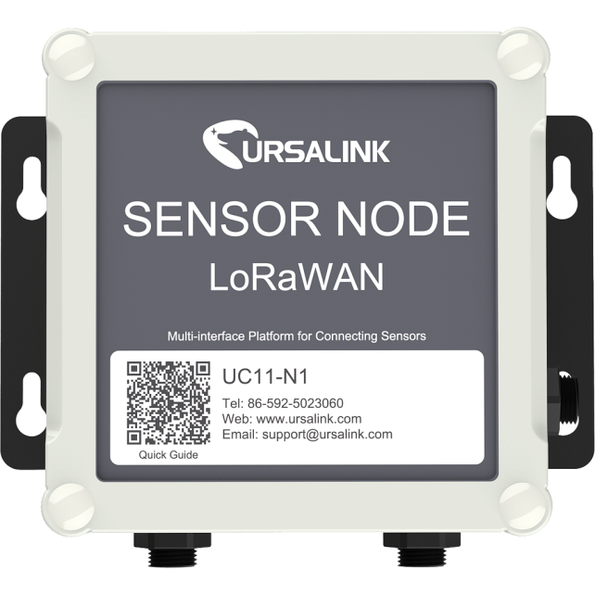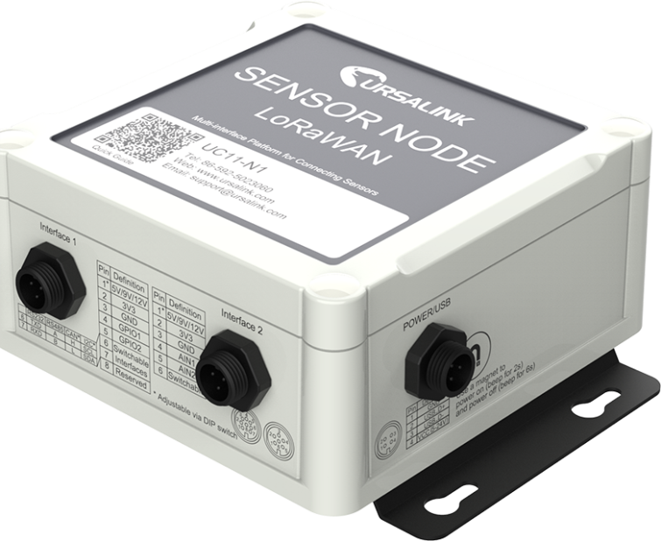
Description
The UC11-N1 is a fully integrated, battery powered LoRaWAN node with multiple communication interfaces for connecting to a wide range of external sensors. With quick installation and easy maintenance, the UC11-N1 is designed to work in harsh environments for remote monitoring and collecting data from sensors.

Specifications
- IP67 waterproof for harsh environments
- Multiple interfaces including serial, I/O, CAN and I2C
- Standard LoRaWAN v1.0/v1.0.2 protocol support
- Ursalink Cloud compliant
- Multiple power supply option: battery, DC or solar
- 5 years life under LoRaWAN Class A mode
- Frequency: IN865
- Tx Power: 20dBm
- Sensitivity: -147dBm @300bps
- Mode: OTAA
- Interface: 2×GPIO, 1×RS232/RS485/CAN/I2C switchable, 1×3.3 V output, 1×5/9/12 V output switchable, 2×Analog input
- Operating Temperature: -20°C to +70°C
- Ingress Protection: IP67
- Dimension: 120.1 × 120.1× 55.4 mm (4.73 × 4.73 × 2.18 in)
- Power Input: 1. 19000mhA replaceable Li-SOCL2 battery
2. 5-24 VDC with 4000mhA battery backup
3. Solar powered with 8000mhA battery

